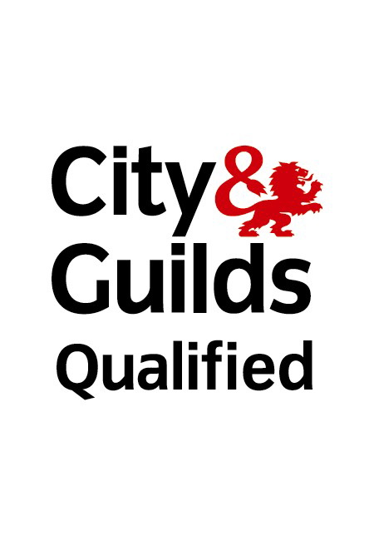
Andrews Creative
Nik and Helen Andrews
15 Probert Road
Wolverhampton
West Midlands
WV10 6UE

Contractor
A.M.R Maintenance
144 Helming Drive
Wolverhampton
West Midlands
07944281624
Certificate of Portable Appliance Testing

The portable equipment of the client as named above has been tested in accordance with City and Guilds 2377-002 regulations. If any discrepancy over this certificate should arise please contact the contractor A.M.R Maintenance who carried out the testing of the portable equipment

Signed: A.M.Roberts
Print: Andrew Mark Roberts
Date of Test: 4th July 2021
Date of Retest : 4th July 2022

